Calibri font style; Paper format 12.5 x 19.5 cm. + header.

ARTICLE TITLE
(Calibri, 14 point font size, bold, UPPER CASE, single spaced)

(11 point font size, italics, single spaced, fully justified - max 200 words) abstract abstract abstract abstract abstract abstract abstract abstract abstract abstract abstract abstract abstract abstract abstract abstract abstract abstract abstract abstract abstract abstract abstract abstract abstract abstract abstract abstract abstract abstract.

Keywords: (11 point font size, italics, single spaced, fully justified) keyword1, keyword2 (three to six keywords separated by comma)

1. Introduction (14 point font size, bold, single spaced)

(12 point font size, single spaced, first line indent 0.5 cm, fully justified) Text text text text text text text text text text text text text text text text text text text text text text text text text text text text text text text text text text text text text text text text text text text text text text text text text.

2. Section 2 (14 point font size, bold; two blank spaces above and one blank space below)

(12 point font size, single spaced, first line indent 0.5 cm, fully justified) Text text text text text text text text text text text text text text text text text text text text text text text text text text text text text text text text text text text text text text text text text text text text text text text text text.
Text text text text text text text text text text text text text text text text text text text text text text text text text text text text text text text text text text text text.

2.1 Sub-section 2.1 (12 point font size, italics, bold; one blank space above and one blank space below)

(12 point font size, single spaced, first line indent 0.5 cm, fully justified) Text text text text text text text text text text text text text text text text text text text text text text text text text text text text text text text text text text text text text text text text text text text text text text text text text.

Footnotes
Number all footnotes consecutively in the order in which they appear in the manuscript with superscript Arabic numerals. Footnote numbers should be superscripted, like this,' following any punctuation mark except a dash (10 point font size).

In-text citations
APA’s in-text citations provide at least the author’s last name and the year of publication. For direct quotations and some paraphrases, a page number is given as well. The abbreviation et al. can be used in the text citation of material with three to five authors (after the initial citation, when all are listed) and in all parenthetical citations of material with six or more authors.

Verbatim quotations from texts or qualitative research data (interviews, newspaper articles, etc.)
The length of a quoted passage is what determines whether it should be inline with the text or set as a block quote. According to APA standards, quoted passages that contain less than 40 words should be inline with the text; quoted passages that contain 40 or more words should be set as block quotes. Block quote starts on a new line and all lines are indented 0.5 cm. from the left margin. If the quoted passage contains more than one paragraph, indent the first line of second and subsequent paragraphs an additional 0.5 cm. from the start of the block quote.

Data, tables, graphs and figures
Numerical data included in the text must follow APA rules. Examples: Younger adults (14 women, 10 men, M_{age} = 19.5 years, age range: 18-22 years) were recruited with flyers posted on the Boston College campus.
These difference scores were then examined with a 2 x 2 x 2 (Age [young, older] x Valence [positive, negative] x Arousal [high, low]) analysis of variance (ANOVA). This ANOVA revealed only a significant main effect of arousal, F(l, 46 ) = 8.41, p = .006, η² = .16, with larger differences between neutral and high-arousal images (M = 137) than between neutral and low-arousal images (M = 93; i.e., high-arousal items processed more quickly across both age groups compare d with low-arousal items).

Tables should be numbered consecutively in Arabic numerals following the order in which they are cited. Each table must have a brief descriptive title on top. Tables should be formatted according to the following style:

Table 1. Table Title. (12 point font size, bold)
 | Younger |  |  | Older
Level of difficulty | n | M (SD) | 95% CI | n | M (SD) | 95% CI
Low | 12 | .05 (.08) | [.02, .11] | 18 | .14 (.15) | [.08, .22]
Moderate | 15 | .05 (.07) | [.02, .10] | 12 | .17 (.15) | [.08, .28]
High | 16 | .11 (.10) | [.02, .17] | 14 | .26 (.21) | [.15, .39]
Note. CI = confidence interval.

Table 2. Correlation, mean scores and standard deviation for gender (0 = female, 1 = male), age, culture maintenance, contact search and sense of community.
 | 1. | 2. | 3. | 4. | 5.
- Gender | -
- Age | .02 | -
- Culture maintenance | .04 | .02 | -
- Contact search | -.03 | .19** | .10* | -
- Sense of community | -.01 | .07 | .08* | .43** | -
Mean | .52 | 38.90 | 8.23 | 9.69 | 61.92
Std. dev. | .50 | 13.76 | 2.86 | 2.27 | 10.44
* p < .01; ** p < .001

Figures can be effectively used to present detailed results and complex relationships and patterns, as in Figure 1, 2 and 3. Each figure must have a figure caption at the bottom, including the figure number.

Var. a1
Var. b1
Var. b1
Var. c1
Var. c2
Var. c3
Figure 1. Figure Title. (12 point font size, bold)
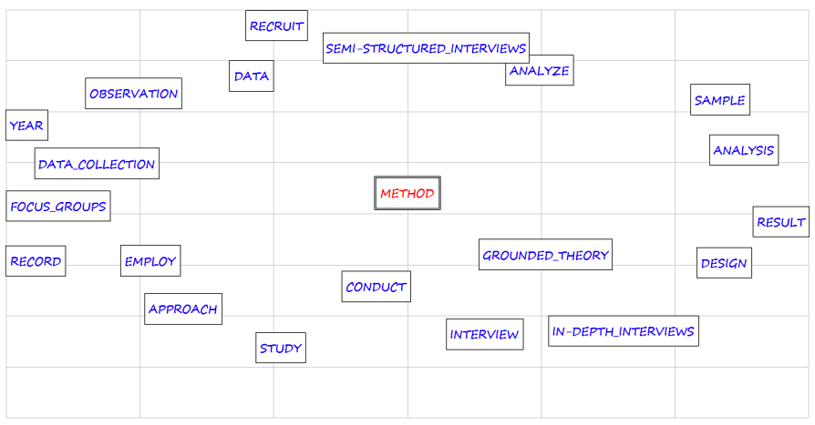
Figure 2. Word associations
-0.8
-0.6
-0.4
-0.2
0.2
0.4
0.6
0.2
-0.2

-0.4
-0.6
-0.8
-1.0
0.4

C4
C1
C3
C2

Albanians

1st Generation
2nd Generation
Italians
Low-contact
High-contact

Figure 3. Correspondence Analysis
Acknowledgement (14 point font size, bold; two blank spaces above and one blank space below)

Acknowledgments of colleagues, grants, funds, etc. should be placed just before the reference list. The names of funding organizations should be given in full (12 point font size).

Text text text text text text text text text text text text text text text text text text text text text text text text text text text text text text text text text text text text text text text text text text text text text text text text text.

References (14 point font size, bold; two blank spaces above and one blank space below)

The reference list has to be in alphabetical order. All references must be complete and accurate. Where possible the DOI for the reference should be included at the end of the reference. Online citations should include date of access. If necessary, cite unpublished or personal work in the text but do not include it in the reference list. References should be listed in APA style, according to the 7th edition (12 point font size, hanging indent 0.5 cm, fully justified) as follows:

Journal article
Hegarty, P., & Buechel, C. (2006). Androcentric reporting of gender differences in APA articles, 1965-2004. Review of General Psychology, 10(2), 377-389. https://doi.org/10.103711089-2680.10.4.377

Book
Sarason, S. B. (1974). The psychological sense of community: Prospects for a community psychology. Jossey-Bass. https://doi.org/10.1080/09614524.2013.772120

Book with more than one author
Kelly, C. & Breinlinger, S. (1996). The social psychology of collective action: Identity, injustice and gender. Taylor & Francis.

Stand-alone web document (no date)
Nielsen, M. E. (n.d.). Notable people in psychology of religion. http://www.psywww.com/psyrelig/psyrelpr.htm

Article or chapter in an edited book
Innes, J.E., & Booher, D.E. (2003). Collaborative policymaking: Governance through dialogue. In M.A. Hajer & H. Wagenaar (Eds.), Deliberative policy analysis: Understanding
governance in the network society (pp. 33-59). Cambridge University Press.

The abbreviation et al. is not used in the reference list, regardless of the number of authors.
Appendix (14 point font size, bold; two blank spaces above and one blank space below)
If the manuscript has only one appendix, label it Appendix; if your manuscript has more than one appendix, label each one with a capital letter (Appendix A, Appendix B, etc,) in the order in which it is mentioned in the main text. In the text, refer to appendices by their labels (12 point font size).

Text text text text text text text text text text text text text text text text text text text text text text text text text text text text text text text text text text text text text text text text text text text text text text text text text.

